Atomic Structure

Name
Institution of Affiliation
Professor
Date

Atomic Structure
Question 1
- ¹⁴₇N Atomic mass=Number of protons+number of neutrons
14= P+N
=7+7
Number of P=7
¹⁵₇N Atomic mass=Number of protons+number of neutrons
15= P+N
=7+8
Number of P=7
¹⁴₇N⁻³ Atomic mass=Number of protons+number of neutrons
14= P+N
=7+7
Number of P=7

- ¹⁴₇N Atomic mass=Number of protons+number of neutrons
14= P+N
=7+7
Number of N=7
¹⁵₇N Atomic mass=Number of protons+number of neutrons
15= P+N
=7+8
Number of N=8
¹⁴₇N⁻³ Atomic mass=Number of protons+number of neutrons
14= P+N
=7+7
Number of N=7

- ¹⁴₇N Atomic number=Number of eletrons
Number of E=7
¹⁵₇N Atomic number=Number of electrons
Number of E=7
¹⁴₇N⁻³ Atomic number=Number of electrons
= -3 means it has gained 3 electrons
Number of E=10

Question 2
- They have same number of electrons and protons
- They have same number of electrons and protons
Question 3
It represents the numbers of electrons in that element and uniquely identifies an element.
Question 4
They have the same number of electrons
Question 5
Protons
Question 6
Number of neutrons and protons
Question 7
Neutrons
Question 8
It shows that the element has lost electrons hence the positive charge since the protons are now more than the electrons.
Question 9
- Electrons
- The particle has gained electrons and that is why it has a negative charge meaning it has more electrons than protons.
- It is determined by subtracting the number of electrons from the number of protons.
Question 10
Isotopic Symbol | Z | A | # of electrons | # of protons | # of neutrons
¹²  C  ₆ | 6 | 12 | 6 | 6 | 6
⁵⁶_{Fe}3+  ₂₆ | 26 | 56 | 26 | 28 | 28
³²  _{S}2-  ₁₆ | 16 | 32 | 18 | 16 | 16
⁹⁸  Mo  ₄₂ | 42 | 98 | 42 | 42 | 56
¹¹⁸  Og  ₄₈ | 48 | 120 | 48 | 50 | 70
 | 16 | 32 | 18 | 16 | 16

Question 11
- ¹³
C
₆

- ⁹⁰
Zr
₄₀

- ⁶¹
Ni ⁺²
₂₆
Question 12
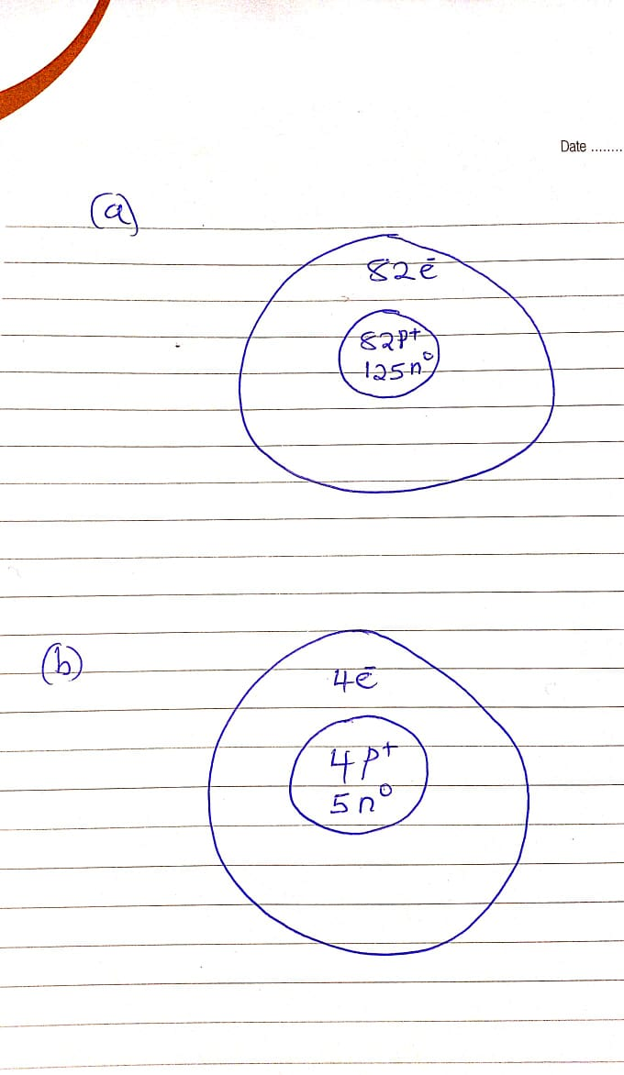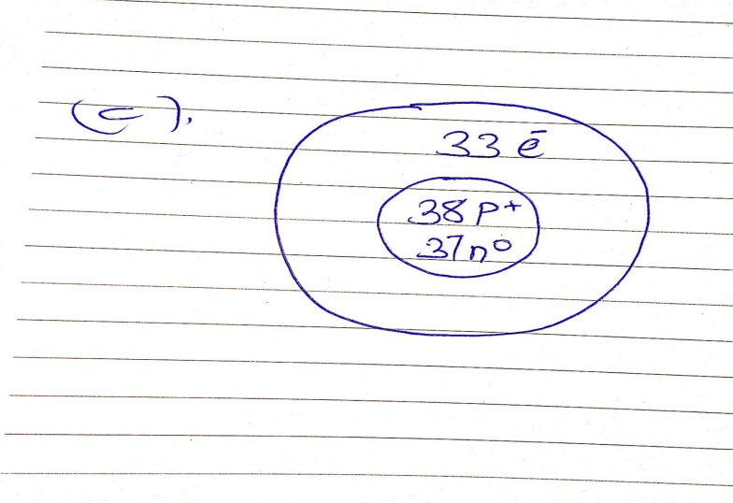
Question 13
- Those that passed through did not in any way find the nuclei on the path. Most of them passed through meaning that the nuclei occupy a small area of the atomic structure.
- This is because the positive charge and the mass of the gold were concentrated in a very small volume in the atom.
- It is because the nucleus of the gold atoms is positively charged.
Question 14
The net charge of an atom is zero. This is because the number of protons is equal to the number of electrons.
Question 15
- 8 protons
- 10 electrons.
Question 16
It has 24 protons and 18 electrons.
Question 17
It has 35 protons and 36 electrons
Question 18
Name | Symbol | Protons | Electrons | Neutrons
Ferric ion | Fe⁺³ | 26 | 23 | 26
 | Ag⁺¹ | 47 | 46 | 61
Silver ion
 | P⁻³ | 15 | 18 | 15
Phosphide ion
Potassium ion | _{K}+1 | 19 | 18 | 19

